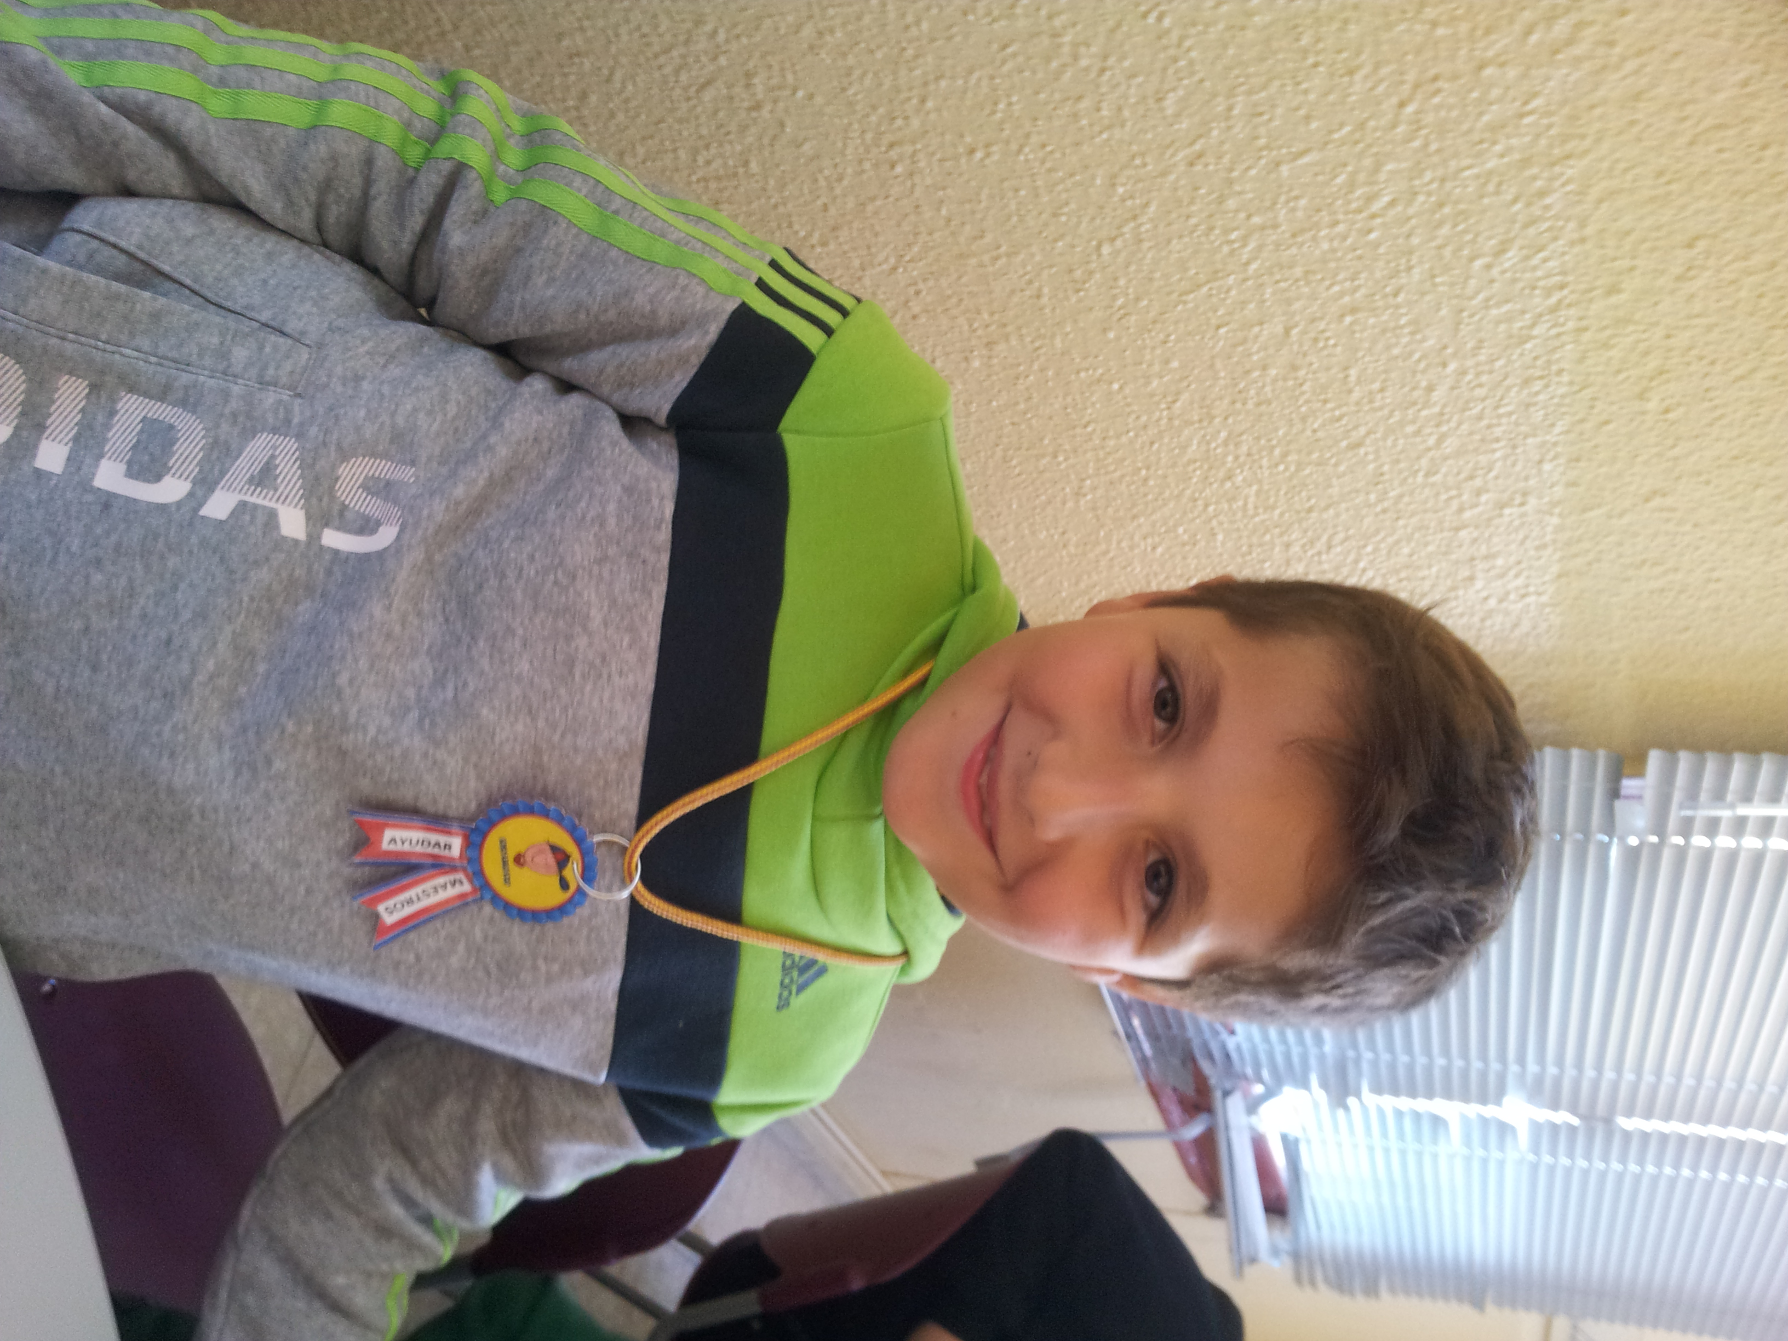

Hello

My name is alvaro .
I´m 9 years old.
I´m from spain.
I live in socuellamos.
I go to school by car .
Today is Friday.
My school´s name is gerardo martinez.
There are twenty-four students in my classroom.
My english teacher is carlos.
My best friend is alonso.

